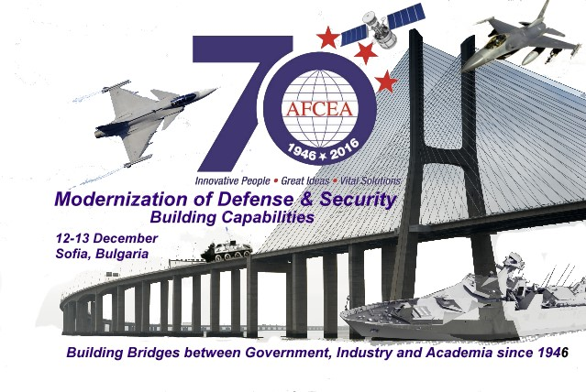
70 YEARS AFCEA JUBILEE CONFERENCE
„Modernization of Defense and Security Sector –
Building Capabilities“
12-13 December 2016
Central Military Club, Sofia

PRELIMINARY PROGRAM
12 December 2016
08:30 – 09:00 Registration
09:00 – 09:25 Official opening – Konstantin Zografov, AFCEA Sofia Chapter President , Official Addresses from MoD, MI, MTITC, ME.
- Defense Staff Address. VADM Emil Eftimov, Deputy Chief of Defense.
- 70 Years AFCEA – Serving Defense and Security – Eng. Dr. Simeon Kralikov, col. (ret.), Honorable Chapter President
09:25 – 10:25 Plenary session „Building capabilities- the core of the modernization process”
- Ministry of Defense Policy on Modernization of Bulgarian Army – Minister/Deputy Minister LTG Atanas Zapryanov (ret.)
- “Research, Technologies and Innovations in the Modernization of the Armed Forces”, Prof. Todor Tagarev, Director of Defense Intitute “Prof. Tsvetan Lazarov”
10:25 Exhibition opened
10:30 – 11:00 Coffee break
11:00- 18:00 Panel I - „Modernization of the Armed Forces”
11:00 – 12:30 Session „Land Forces“
- Keynote from Land Forces,” Main Requirements and Key Characteristics of the New Armoured Combat Vehicle for the Land Forces”, BGEN Michail Popov, Deputy Commander of Land Forces
- Presentations
  - Rheinmetall – Silver Sponsor, Peter Ruckstuhl, Marketing Director.
  - TEXTRON capabilities for modernization of the Land Forces, Barry (Bear) Midkiff
  - Patria (presence)
  - General Dynamics European Land Systems (presence), MR. Nico Danneberg
12:30 – 13:45 Networking lunch
13:45 – 15:45 Session „Air Force“
- Keynote from Air Forces, MG Tsanko Stoykov, Commander of Air Force
- Presentations:
  - SAAB Gripen “The Gripen Mission”, Daniel Boestad - Vice President, Head of Gripen, Central and Eastern Europe
  - Lockheed Martin Aeronautics, “F-16 – solution for Bulgarian Air Force”, Gregg Brough, F-16 Development Manager
  - “IAI Unique F16 Proposal for Bulgaria”, Mr. Netta Kerem, Director Marketing
15:45 – 16:45 Coffee break
16:00 – 18:30 Session „Navy“
- Keynote from Navy, Capt. Navy Svilen Georgiev, Navy Command
- Presentations:
  - DAMEN Shipyards, “Modular Sigma”, Mr Michiel van Ginkel
  - MTG Dolphin, “Modernization and Defelopment of the Navy – Bulgarian Industry Perspective”, Mr Svetlin Stoyanov, CEO
  - DCNS France,”Gowind 2500, a multi role corvette: from low force maritime security mission to high intensity combat”, Yves Cotty, International Sales Department
  - IHB Shipdesign, “Bulgarian HighTech Capacity for Partnership in Arned Forces Modernization”, Mr. Boyko Georgiev, CEO
18:30 – 20:30 Cocktail
13 December 2016
08:30 – 09:00 Registration
09:00 – 10:30 Panel II „Technical Aspects of Protection of National and European Air, Maritime and Land borders and responding to Migrants pressure“
      - “New Opportunity to Provide Border Security of Bulgarian Sea Border”, Technical University Varna, Assoc. Prof. Tchavdar Ormanov
      - Presentation from Maritime Administration, Common Information Sharing Environment (CISE), Petar Kirov, Secretary General of EAMA, Contraadmiral (ret.) Georgi Motev, Director General directorate “Search and Rescue”.
10:30 – 10:45 Coffee break
10:45 – 13:45 Panel III „Information and Cyber Security and Resilience“
10:45 – 12:00 Session „Preparedness of the Society to answer current Threats and Cyber Crimes“
- Keynote from Ministry of Transport: „Network and Information Security in Bulgaria – Challenges“, Vassil Grancharov, Director Network and Information Security“
- Presentation from Ministry of Interior
- Presentations:
  - Telepoint. „ Israeli Experience in Cybersecurity and Radware solutions for Attacks Prevention", Mr Hristo Angelov
12:00 – 13:45 Session „Critical Infrastructure protection“
- Keynote from Ministry of defense: "Comprehensive Approach to the Protection of Airfield Infrastructure", col. Assoc. prof. Atanas Madjarov.
- „Protection of Energy Infrastructure“, Nedyalko Angelov, Ministry of Energy
- Presentation
  - LIREX: “Modern Integrated Physical Protection Systems”
13:45 – 14:45 Working lunch and Conclusions
14:45 Closing of Conference and Exhibition

